Name: Mpho Mugogovhali
Subject: WEB
Proposal 1: The Daily Grind Café

- Organisation Overview
Located at 7 7th Ave., Melville, Johannesburg, South Africa, The Daily Grind Café is a charming little bakery and coffee shop. It’s designed to be a welcoming community centre where people can enjoy delicious coffee, eat freshly baked goods, and relax in a comfortable setting. It primarily draws locals, freelancers, and students. The café wants to “brew community, one cup at a time,” and it sees itself as the neighbourhood’s favourite place for people to get together, work, relax, and enjoy quality food and beverages.
- Website Goals, Objectives and KPIs
The website’s main goals are to establish a professional online presence and guarantee that customers can easily access important information. It will highlight the café, its menu, provide contact information and location details, and encourage customers to ask questions. Three KPIs will be used to measure success: The number of monthly website visitors, the total number of inquiries submitted, and the number of visits to the menu page.
- Website Need
The Daily Grind Café requires an online presence where customers can readily access crucial information before visiting, as it is a fictional business without a website. The website will act as a central location for the café’s location, phone number, menu, and operating hours.
- Proposed Features and Functionality
The homepage, about, menu, enquiry, and contact are the five main pages of the website. The homepage will feature calls to action along with an overview of the café. Its vision, mission, and history will be discussed on the About page. The menu will highlight baked goods, coffee, and light meals. The contact page will include the café’s address, phone number, email, hours of operation, and a map, while the inquiry page will feature a form for customer’s questions.
- Design and user experience
The website will use forest green, natural green, earthy brown, cream, and warm yellow. These colours represent plants, soil, food, and the sense of community. Large photos of gardens, fresh vegetables, and local events will help create a warm, welcoming look. With clear headings, easy navigation, and readable text, the site will be simple for everyone to use.
- Timeline and Milestones
Week | Milestones
1. | Planning, proposal, sitemap and wireframes
2. | HTML development and content
3. | Website styling and functionality
4. | Testing and final corrections

- Sitemap
- Home:
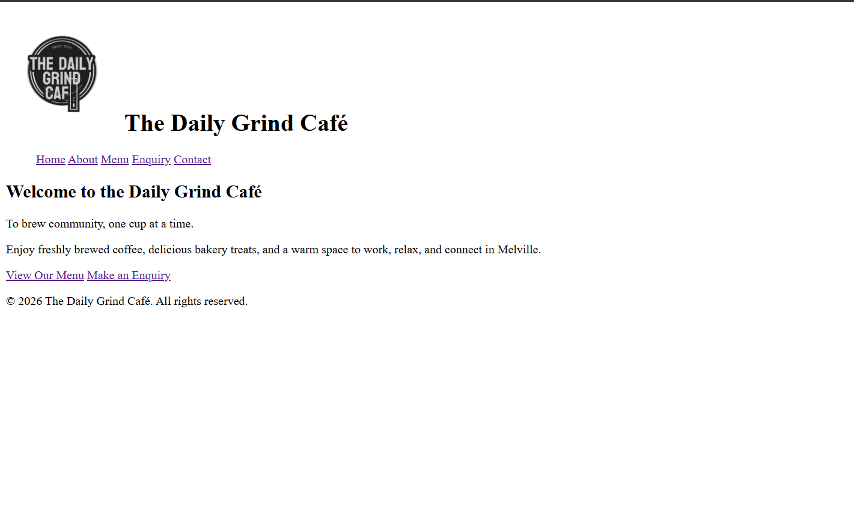

- About:
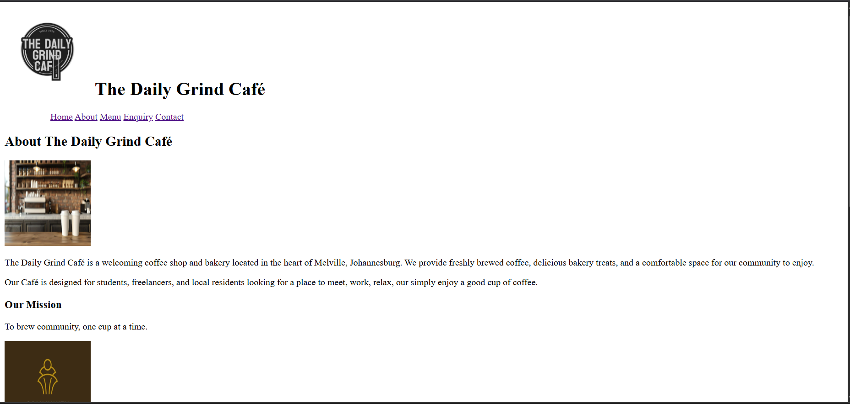

- Menu:
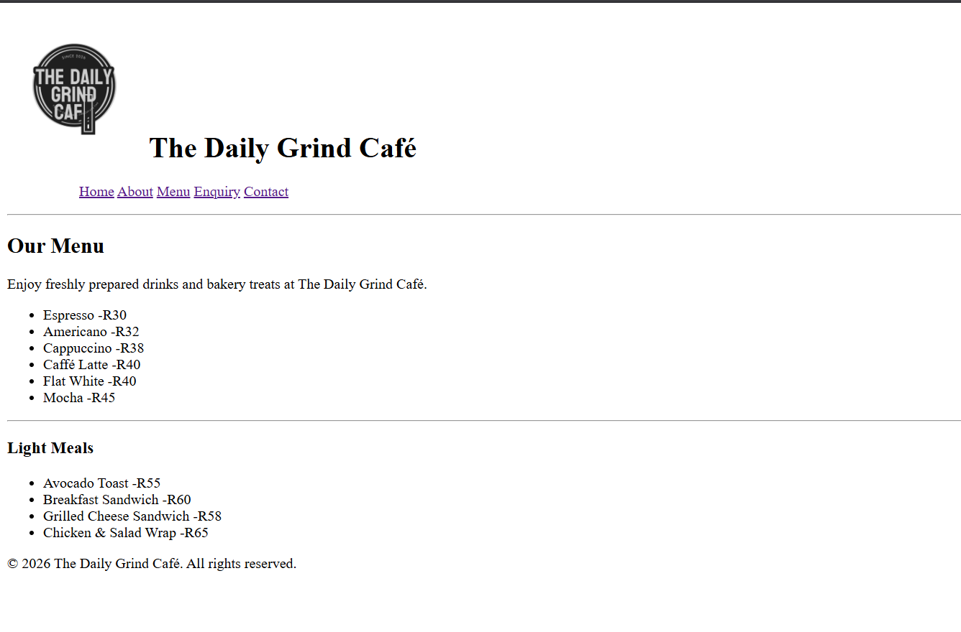

- Contact:
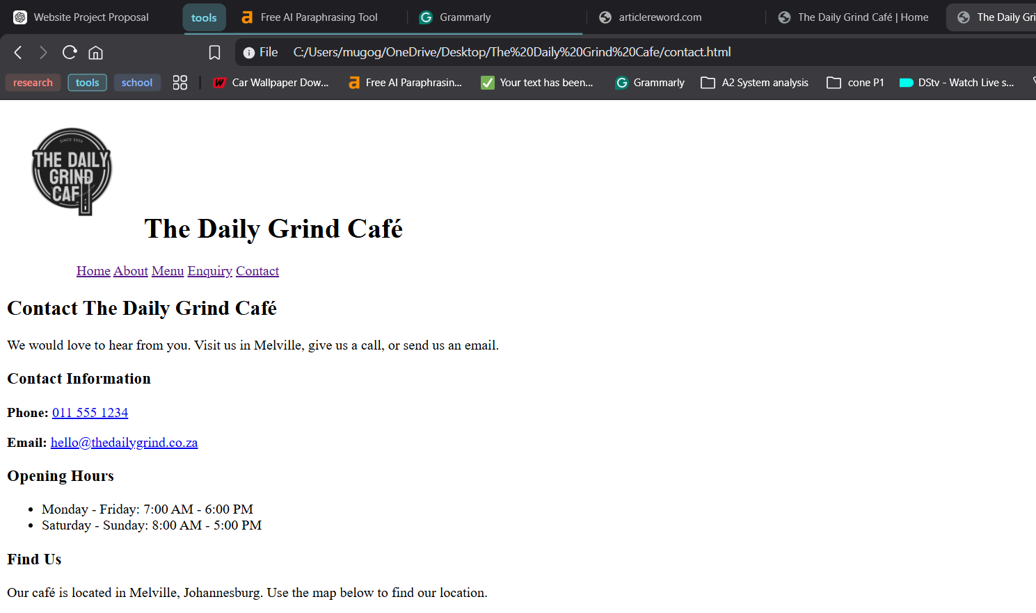

- Changelog
Version 1.0: initial website proposal completed.

